Unit-I
2016
Q. a) Explain Merge sort and compute the analysis of Merge sort.
b) Perform the quick sort to sort the following numbers:
20, 40, 50, 15, 10, 5, 80, 90.
Q. a) Explain Strassen’s algorithm for matrix multiplication.
b) Apply Strassen matrix for multiplication algorithm to multiply the following matrices:
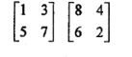
2018
Q. a) Sort the above elements using merge sort. Write the recursion tree.
b) Write an algorithm for quick sort. Derive the worst case time efficiency of the algorithm.
2019
Q. a) For the algorithm of quick sort, define its best case, average case, and worst case analysis.
b) Explain Strassen matrix multiplication using example. State its complexity.
Q. Solve the following recurrence relation:
  - T(n)= 3T(n/3)+n³
  - T(n)= 9T(n/3)
  - T(n)= 2T(n-2)+n
Q. Write an algorithm for Quick Sort. Find its average case and worst case performance analysis.
Q. Why do we use asymptotic notations in the study of algorithms? Briefly describe the commonly used asymptotic notations.
Unit-II
2016
Q. a) Explain the difference between Kruskal’s and Prim’s algorithm with the help of suitable example.
b) What is an optimal Huffman code for the following set of frequencies:
a:1, b:1, c:2, d:3, e:5, f:8, g:13, h:21.
Q. Illustrate Dijkstra’s and Bellman Ford Algorithm for finding the shortest path.
2018
Q. a) Construct Huffman code for the following set of frequencies:
 | a | b | c | d | e | f
Frequency | 45 | 13 | 12 | 16 | 9 | 5

b) Compare fixed-length and variable-length codewords and the amount of saving took place.
Q. a) State and explain the functioning of Dijkstra’s algorithm for single source shortest path. . Also proof the correctness of Dijkstra’s algorithm.
Q. a) Apply PRIMS algorithm for the following graph to find minimum spanning tree.
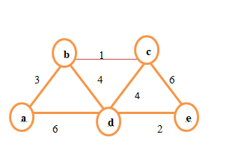
2019
Q. a) Write an algorithm for Huffman code and explain. Which kind of strategy is used in the algorithm among Divide and Conquer method, Dynamic Programming and greedy paradigm? Justify your choice.
b) Find the Huffman code for variables A B C D E F G H with frequencies 0.25, 0.25, 0.14, 0.14, 0.055, 0.055, 0.055, 0.055, 0.055 respectively.
Q. a) What are the various ways to internally store a graph? Explain.
b) Represent the following graph in all ways discussed in section (a)
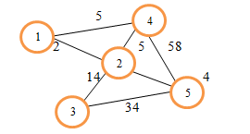
Q. a) Explain the working of Dijkstra algorithm of following graph
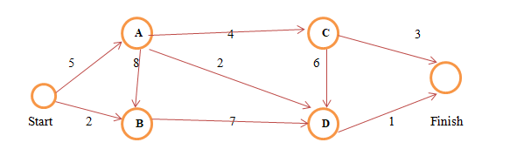
b) Compare the complexities and capabilities of Dijkstra algorithm with Bellman-Ford Algorithm.
Q. a) Explain topological sort using neat written algorithm.
b) Perform topological sort on the following graph
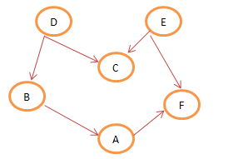
Q. Consider following activities with their start/finish time
Activity | Start Time | Finish Time
A | 1 | 10
B | 2 | 4
C | 4 | 9
D | 5 | 7
E | 7 | 10
F | 10 | 12
Apply greedy strategy to select the activity in order to optimize throughput.
Q. Find single source shortest path for the following graph using Dijkstra’s algorithm. Assume node 1 as source. Also analyze time complexity of Dijkstra Algorithm.
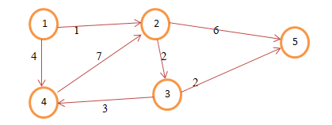

Unit-III
2016
Q. a) Explain Floyd Warshal algorithm.
b) Apply Floyd Warshal algorithm for constructing shortest path.
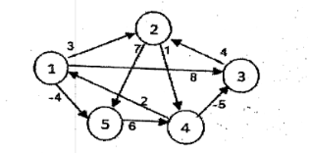
Q. a) What does Dynamic Programming have common with Divide and Conquer and what are differences?
b) Determine the LCS of <A,B,C,B,D,A,B> and <B,D,C,,A,B,A>.

2018
Q. a) Find an optimal parenthesization of matrix-chain product whose dimensions are:
(5,10,3,12,5,50,6).
b) Write an algorithm for matrix-chain multiplication that actually performs optimal multiplications.
Q. a) Explain the ingredients of Dynamic Programming and greedy Programming and compare both.
b) Define matroids. How they are useful?
Q. a) Write greedy method control abstraction for subset paradigm.
b) Explain the optimal binary search tree with example.
2019
Q. a) Write an algorithm for matrix-chain multiplication and explain.
b) Perform an optimal parenthesization to find optimum answer for the following set of matrices for multiplication using dynamic programming.
A[3][5], B[2][10], C[10][3].
Q. a) Write the optimal binary search tree algorithm and explain it with the help of example.
b) Use Dynamic Programming to find the longest common subsequence of following two string <011010> and <10110>.
Q. Consider following Knapsack problem in which there are three objects, with weights w={1,2,3} and values v={2,3,4}. The Knapsack capacity of Knapsack is 3. Find the maximum possible value of Knapsack using Dynamic programming.
Q. Compare various representations of disjoint sets. List the application and heuristics for disjoint set.
Q. Apply dynamic programming to find optimal subsequence for multiplication. A1[5,x,4], A2[4,x,3], A3[3,x,2] and A4[2,x,9]. Also find the optimal paranthesization of matrices.
Unit-IV
2016
Q. a) Give Knuth Morris Pratt algorithm for pattern matching.
b) Explain NP completeness reduction with an example.
Q. a) Explain Rabin-Karp string matching algorithm.
b) What is finite automata and its significance to match a string with algorithm and complexity.
2018
Q. a) What are P, NP, NP hard and NP-complete problems? Explain with example.
b) What is reducibility? Explain with examples.
Q. a) Explain Rabin-Karp algorithm for string matching. What is spurious hit?
b) Show if working modulo q=11, how many spurious hit does the Rabin-Karp matches encounter in the following text if looking for the pattern p=26, T= 3141592653589793
2019
Q. Explain String matching finite automata with the help of suitable example.
Q. a) State and explain Knuth-Morris-Pratt String matching algorithm. Compare its complexity with Naïve String matching.
b) Suppose, t=115623590231415 and p= 314, perform the string matching using Knuth-Morris-Pratt string matching algorithm.
Q. Prove that Vertex Cover Problem is NP-Complete. List few more NP complete problems.
Q. Write Pseudo code for Rabin Karp algorithm for sting matching. Apply Rabin Karp algorithm for finding the pattern 1232 into the text 123451232312323145.
Short Questions
2016
Q. Define little omega and little oh notation.
Q. What is recursion tree method?
Q. Write a short note on memorization.
Q. What is optimal substructure and overlapping substructure?
Q. What are the applications of minimum spanning tree?
Q. Explain fractional Knapsack problem.
Q. Differentiate between Dynamic Programming and Greedy approach.
Q. What is Matroid?
Q. Write Naïve string matching algorithm.
Q. Explain NP hard problem briefly.
2018
Q. Substitution method for finding complexity.
Q. Spanning tree and its usefulness in real life.
Q. BFS and its differences with DFS.
Q. Median and order statistics.
Q. Strassen’s matrix multiplication.
Dec 2018
Q. What are lower bounds? Explain the four methods used to establish lower bounds of algorithm.
Q. What is Amortized analysis? What is the time complexity of following function fun()? Explain
Int fun (int n)
{
for(int i=1; i<=n;i++)
{
for(int j=1; j<n;j+=i)
{
Sum=sum+i*j;
}
}
Return(sum);
}
Q. Explain the basic principle of divide and conquer method and compare it with dynamic programming and greedy paradigm.
Q. What are various asymptotic notations? Give their properties.
Q. What are the features of an efficient algorithm? Explain with an example.
2019
Q. What are lower and upper bounds? Explain asymptotic notations.
Q. Compare divide and conquer method for with dynamic programming and greedy paradigm.
Q. Sort the following elements using merge sort
70,20,30,40,10,50
Q. Give the characteristics of NP complete problems and enlist three examples of NP-Complete problems.
Q. Explain reducibility using suitable examples.
Q. Apply PRIMS algorithm for the following graph to find minimum spanning tree:
5
e
b
d
c
a
2 4
3 5

7 6

4
Dec 2019
Q. Design an efficient algorithm to find the minimum and maximum of an array having n distinct elements.
Q. List the desirable characteristics of a good algorithm.
Q. Compare divide and Conquer, Dynamic Programming and Greedy approach.
Q. Show the relationship between Class P, Class NP, NP Complete and NP hard problems.
Q. Find an optimal Huffman code for the following set of frequency a: 40, b: 15, c: 15, d: 20, e: 6, f: 4.
Q. Explain Strassen’s matrix multiplication. How much time is saved if this method is used instead of normal method?

